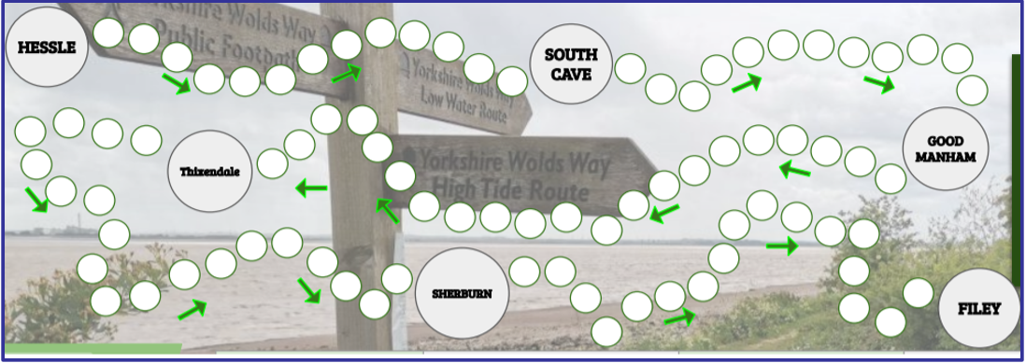

**Wolds Way Challenge**

Every time you go out for a walk, run, bike or scoot simply colour in one marker.

When you have coloured in all the markers you've completed the Virtual Wolds Way Challenge!

To submit your challenge simply return to your PE teacher or email pdm@cottinghamhigh.net